Linear velocity
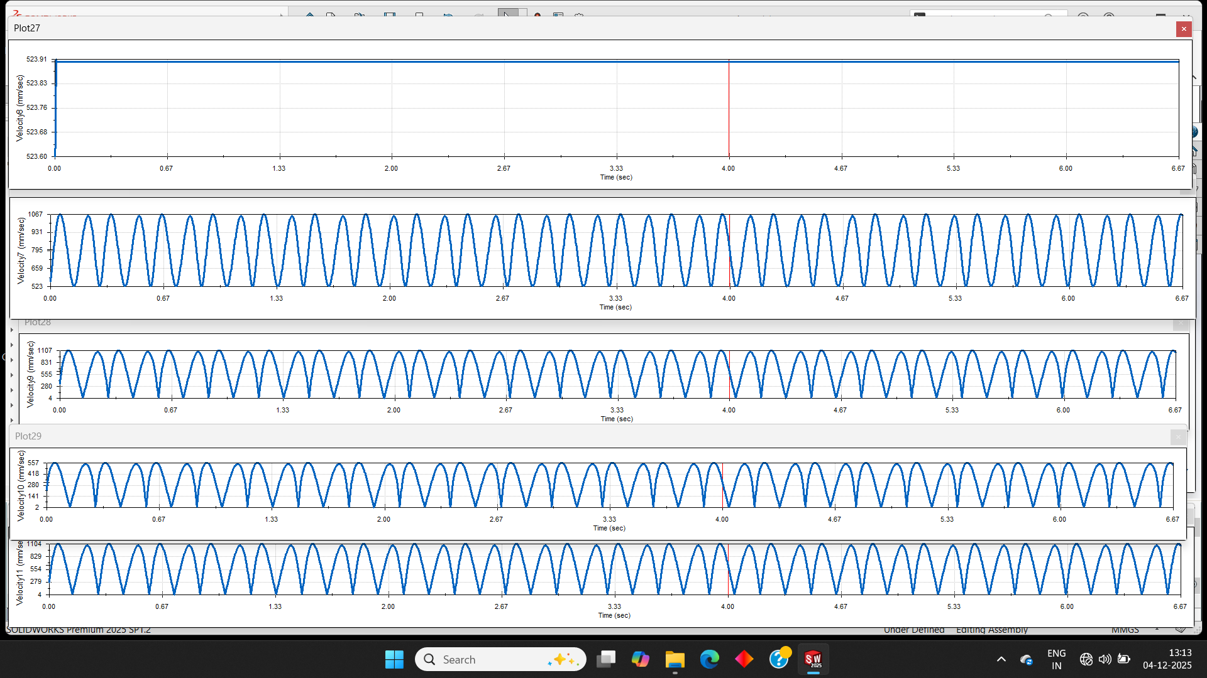
- Link AO 2. Link AS 3. Link BS 4. Link BQ 5. Slider

Angular Velocity
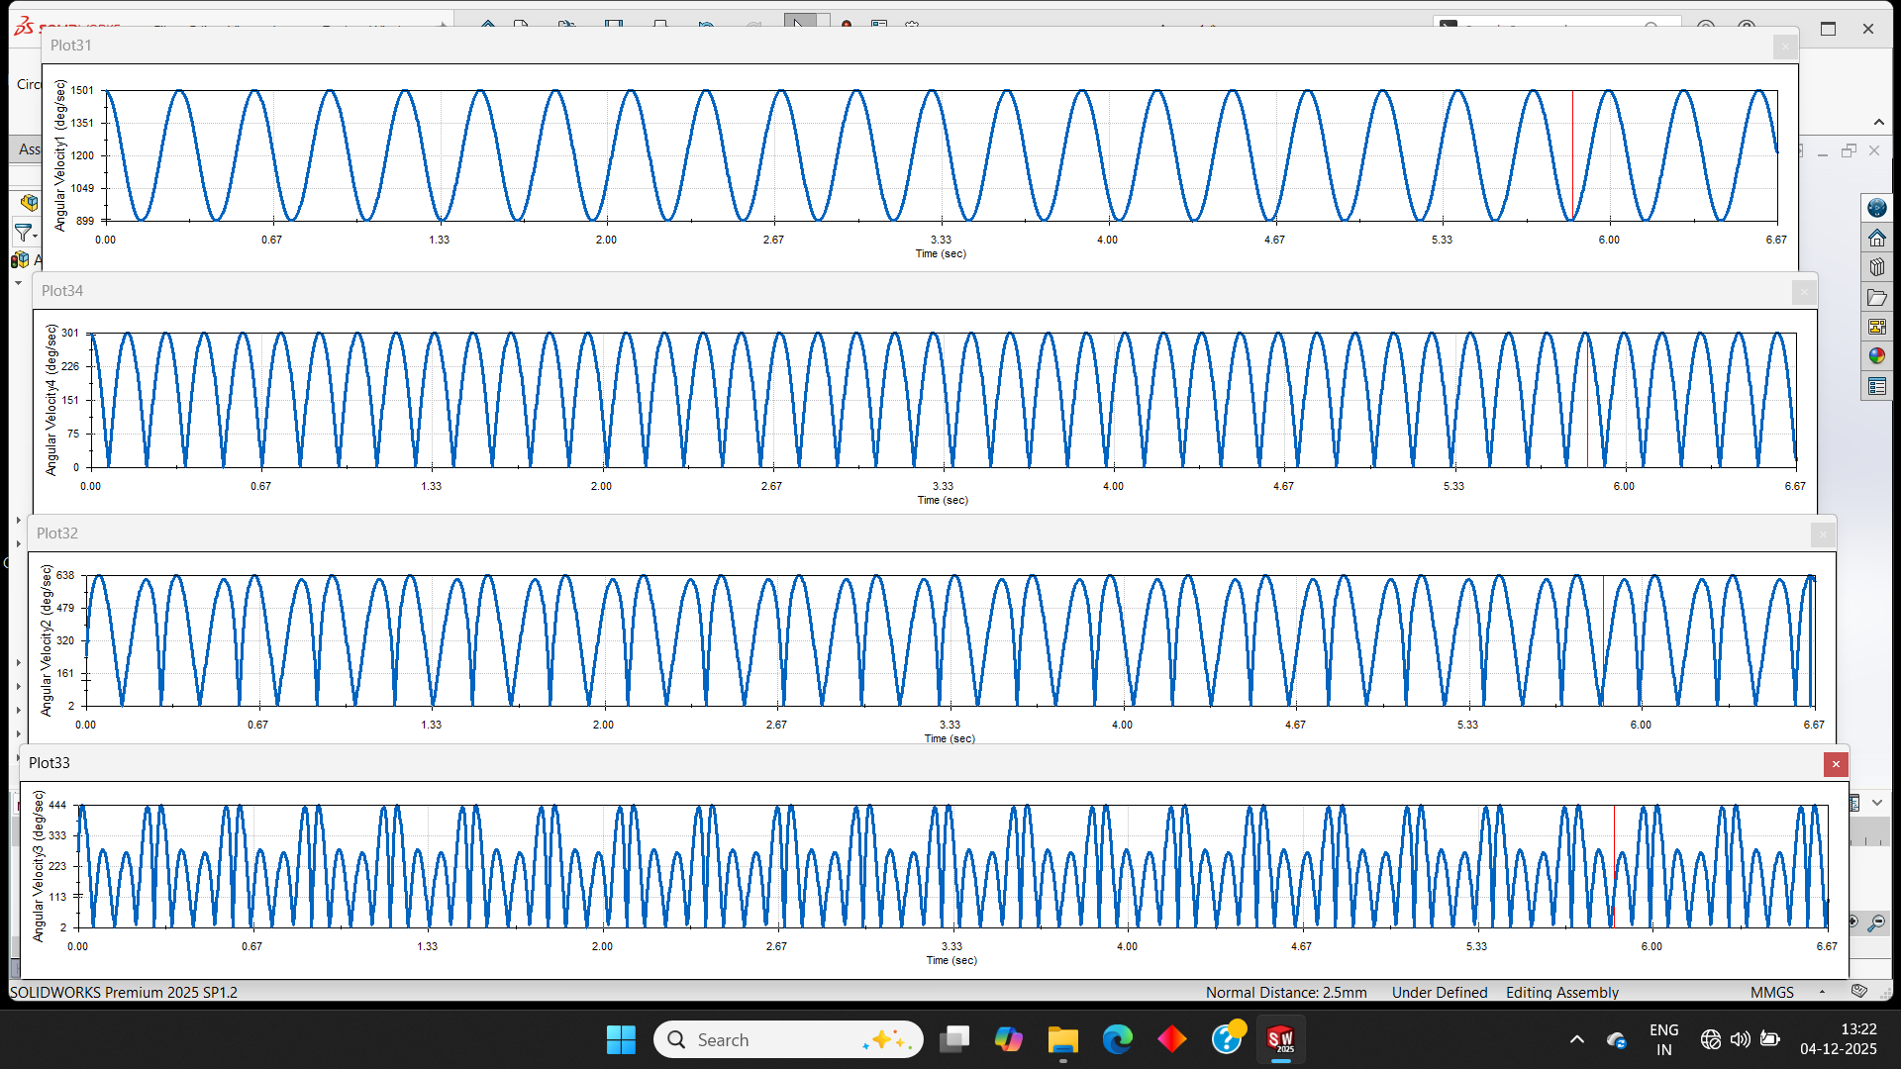
- Link AO 2. Link AS 3. Link BS 4. Link BQ

Linear Acceleration
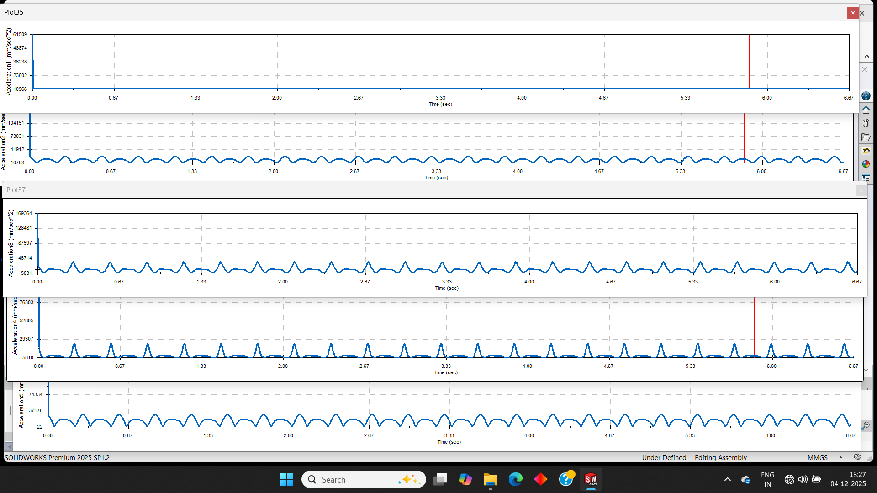
- Link AO 2. Link AS 3. Link BS 4. Link BQ 5. Slider

Angular acceleration
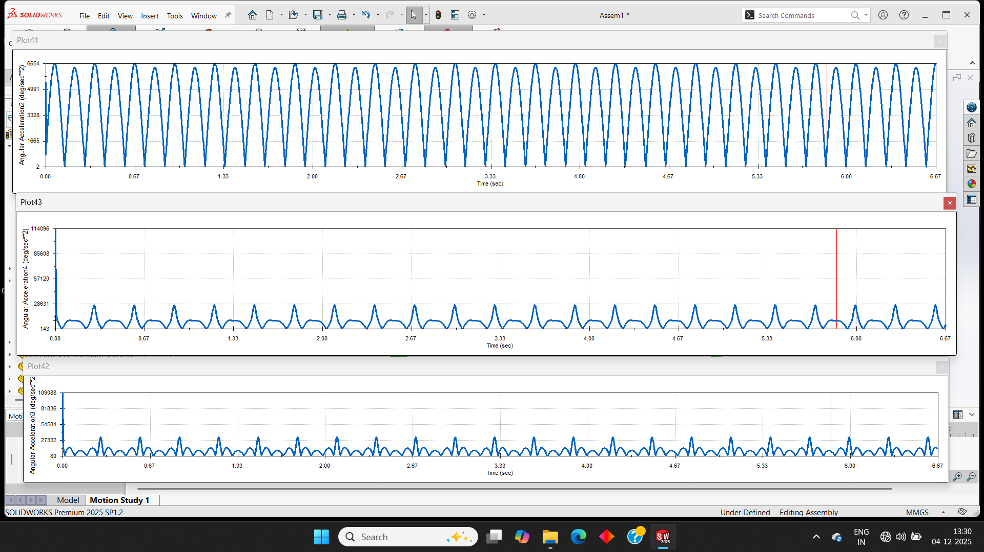
1. Link AS 2. Link BS 3. Link BQ

